**//Source code**

**import** java.util.ArrayList;

**import** java.util.Collections;

**import** java.util.Scanner;

**public** **class** Main {

**public** **static** **void** main(String[] args) {

/*System.out.println("Hello World!");*/

System.***out***.println("\n**************************************\n");

System.***out***.println("\tWelcome to TheDesk \n");

System.***out***.println("**************************************");

*optionsSelection*();

}

**private** **static** **void** optionsSelection() {

String[] arr = {"1. I wish to review my expenditure",

"2. I wish to add my expenditure",

"3. I wish to delete my expenditure",

"4. I wish to sort the expenditures",

"5. I wish to search for a particular expenditure",

"6. Close the application"

};

**int**[] arr1 = {1,2,3,4,5,6};

**int** slen = arr1.length;

**for**(**int** i=0; i<slen;i++){

System.***out***.println(arr[i]);

// display the all the Strings mentioned in the String array

}

ArrayList<Integer> arrlist = **new** ArrayList<Integer>();

ArrayList<Integer> expenses = **new** ArrayList<Integer>();

expenses.add(1000);

expenses.add(2300);

expenses.add(45000);

expenses.add(32000);

expenses.add(110);

expenses.addAll(arrlist);

System.***out***.println("\nEnter your choice:\t");

Scanner sc = **new** Scanner(System.***in***);

**int** options = sc.nextInt();

**for**(**int** j=1;j<=slen;j++){

**if**(options==j){

**switch** (options){

**case** 1:

System.***out***.println("Your saved expenses are listed below: \n");

System.***out***.println(expenses+"\n");

*optionsSelection*();

**break**;

**case** 2:

System.***out***.println("Enter the value to add your Expense: \n");

**int** value = sc.nextInt();

expenses.add(value);

System.***out***.println("Your value is updated\n");

expenses.addAll(arrlist);

System.***out***.println(expenses+"\n");

*optionsSelection*();

**break**;

**case** 3:

System.***out***.println("You are about the delete all your expenses! \nConfirm again by selecting the same option...\n");

**int** con_choice = sc.nextInt();

**if**(con_choice==options){

expenses.clear();

System.***out***.println(expenses+"\n");

System.***out***.println("All your expenses are erased!\n");

} **else** {

System.***out***.println("Oops... try again!");

}

*optionsSelection*();

**break**;

**case** 4:

*sortExpenses*(expenses);

*optionsSelection*();

**break**;

**case** 5:

*searchExpenses*(expenses);

*optionsSelection*();

**break**;

**case** 6:

*closeApp*();

**break**;

**default**:

System.***out***.println("You have made an invalid choice!");

**break**;

}

}

}

**if**(options>6) {

System.***out***.println("You have made an invalid choice!");

}

}

**private** **static** **void** closeApp() {

System.***out***.println("Closing your application... \nThank you!");

}

**private** **static** **void** searchExpenses(ArrayList<Integer> arrayList) {

**int** leng = arrayList.size();

**int** s=0;

System.***out***.println("Enter the expense you need to search:\t");

//searching for expense in arrayList

Scanner sc= **new** Scanner(System.***in***);

**int** search=sc.nextInt();

**for**(**int** i=0;i<leng;i++) {

**if**(arrayList.get(i)==search) {

System.***out***.println("Expense found at index "+i+" and the search key is "+arrayList.get(i)+"\n");

s=1;

}

}

**if**(s==0) {

System.***out***.println("Sorry,expense not found!!\n");

}

}

**private** **static** **void** sortExpenses(ArrayList<Integer> arrayList) {

**int** arrlength = arrayList.size();

//Sorting expenditures in ascending order.

**for**(**int** i=0;i<arrlength;i++){

**for** (**int** j=1;j<(arrlength);j++){

**if**(arrayList.get(j-1)>arrayList.get(j)){

Collections.*swap*(arrayList, j-1, j);

}

}

}

System.***out***.println("The expenditures after sorting are: "+arrayList+"\n");

}

}

//Screenshots

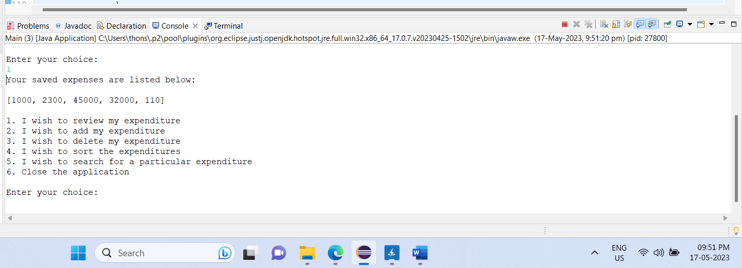

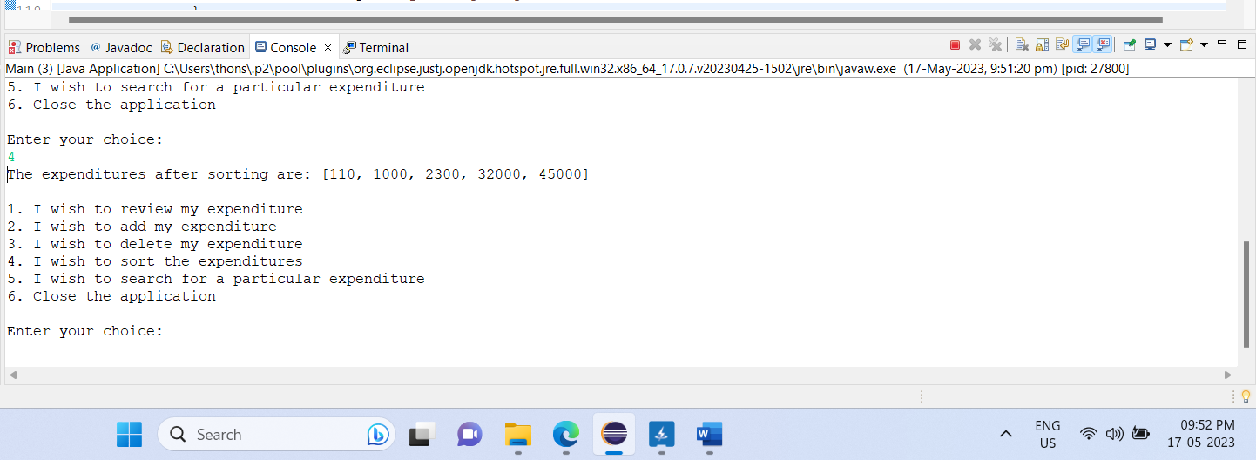

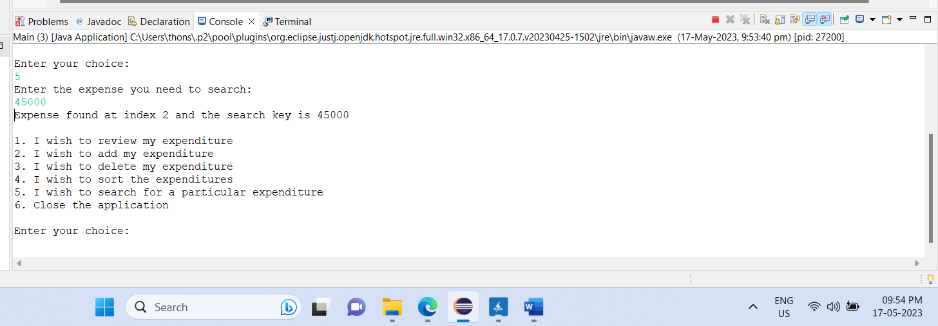

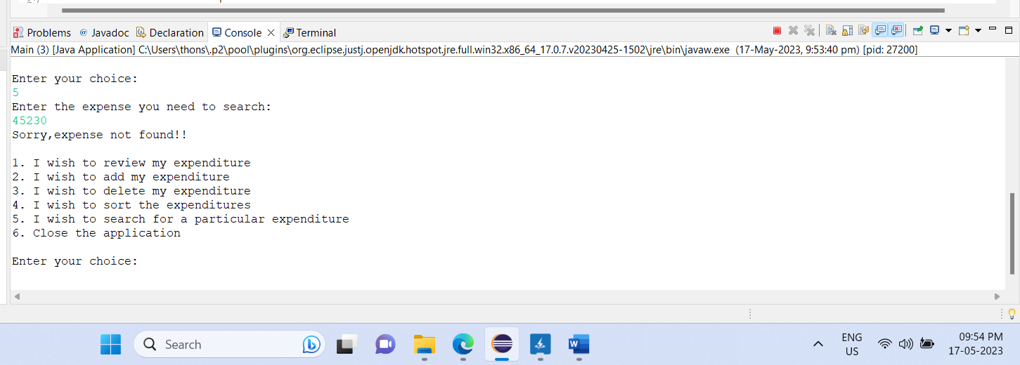

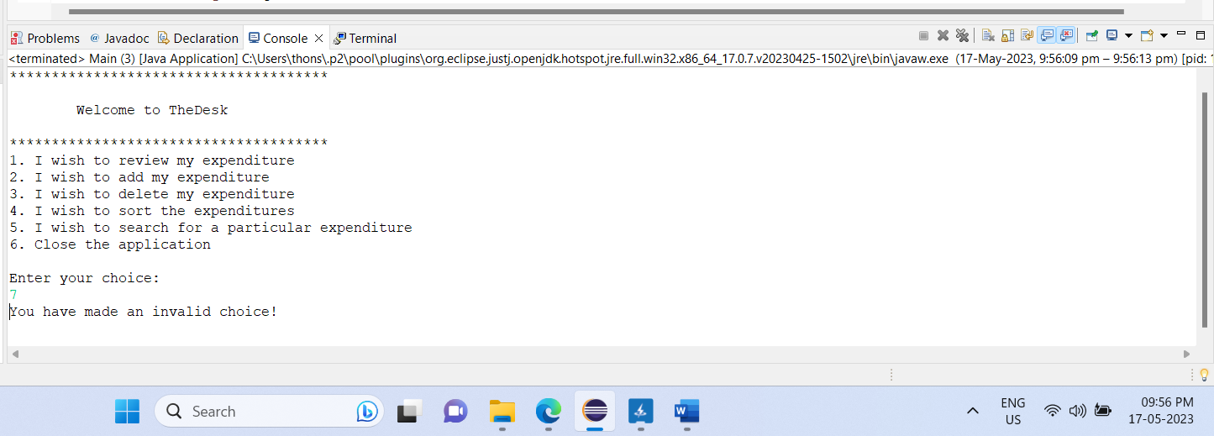

//Writeup

Writing the source code that are missing in the Desk Application

1. Initialize the function "searchExpenses" with the parameter "arrayList".

2. Get the length of the arrayList and assign it to the variable "leng".

3. Initialize a variable "s" to 0.

4. Print "Enter the expense you need to search:\t".

5. Read the user input and store it in the variable "search".

6. Iterate from 0 to "leng" (exclusive) using the variable "i".

- If the element at index "i" in the arrayList is equal to "search":

- Print "Expense found at " + i + " and the search key is " + arrayList.get(i) + "\n".

- Set "s" to 1.

7. If "s" is still 0:

- Print "Sorry, expense not found!!\n".

8. Initialize the function "sortExpenses" with the parameter "arrayList".

9. Get the length of the arrayList and assign it to the variable "arrlength".

10. Iterate from 0 to "arrlength" (exclusive) using the variable "i".

- Iterate from 1 to "arrlength" (exclusive) using the variable "j".

- If the element at index "j-1" in the arrayList is greater than the element at index "j":

- Swap the elements at index "j-1" and "j" using the Collections.swap method.

11. Print "The expenditures after sorting are: " + arrayList + "\n".